**Hospital Management system**

**by Aditya joshi(15BCB0078)**



**School of Computer Science and Engineering**

**DECLARATION**

We hereby declare that the project entitled **“Hospital management system”** submitted by us to the School of Computer Science and Engineering, VIT University, Vellore-14 in partial fulfillment of the requirements for the award of the degree of **Bachelor of Technology in Computer Science and Engineering** is a record of bonafide work carried out by us under the supervision of **Ramanathan L, Assistant**

**Professor (Selection Grade).** We further declare that the work reported in this project has not been submitted and will not be submitted, either in part or in full, for the award of any other degree or diploma of this institute or of any other institute or university.

Signature

**Aditya joshi (15BCB0078)**



**School of Computer Science and Engineering**

**CERTIFICATE**

The project report entitled “**Hospital management system**” is prepared and submitted by **Candidate Aditya joshi (Register No: 15BCB0078).** Ithas been found satisfactory in terms of scope, quality and presentation as partial fulfillment of the requirements for the award of the degree of **Bachelor of Technology in Computer Science and Engineering** in VIT University, India.

**Guide**

**(Name & Signature)**

**Internal Examiner External Examiner (Name & Signature) (Name & Signature)**

**ACKNOWLEDGEMENT**

We would like to express our special thanks of gratitude to our teacher Ramanathan L as well as our HOD Senthilkumar R who gave us this opportunity to do this project on the topic “Hospital management system”, which also helped us in doing a lot of Research and we came to know about so many new things. We are really thankful to them. Secondly, we would also like to thank our parents and friends who helped us a lot in finishing this project within the given time frame. We can’t get a better opportunity than this to increase our knowledge and skill. Thanks again to all who helped us.

Guide : Ramanathan L

Head of the Department : Senthilkumar R

Dean, SCOPE

VIT University

**CONTENTS**

**Chapter Title Page**

Title Page i

Declaration ii

Certificate iii

Acknowledgement iv

Table of Contents v

List of Tables vi

List of Figures vii

List of Abbreviations viii

Abstract ix

1. Introduction
   1. Theoretical Background
   2. Motivation
   3. Aim of the proposed Work
   4. Objective(s) of the proposed work
   5. Report Organization
2. Literature Survey
   1. Survey of the Existing Models/Work
   2. Summary/Gaps identified in the Survey
3. Overview of the Proposed System
   1. Introduction
   2. Framework, Architecture or Module for the Proposed System(with explanation)
   3. Proposed System Model(ER Diagram/UML Diagram/Mathematical Modeling)
4. Proposed System Analysis and Design(As Per IEEE Standard)
   1. Introduction
   2. Requirement Analysis
      1. Functional Requirements
         1. Product Perspective
         2. Product features
         3. User characteristics
         4. Assumption & Dependencies
         5. Domain Requirements
         6. User Requirements
      2. Non Functional Requirements
         1. Product Requirements
            1. Efficiency (in terms of Time and Space)
            2. Reliability
            3. Portability
            4. Usability
      3. Engineering Standard Requirements (Explain the applicability for your work w.r.to the following operational requirement(s))

* Economic
* Environmental
* Social
* Political
* Ethical
* Health and Safety
* Sustainability
* Legality
* Inspectability
  + 1. System Requirements
       1. H/W Requirements(details about Application Specific Hardware)
       2. S/W Requirements(details about Application Specific Software)

1. Results and Discussion(As Per IEEE Standard)
   1. Sample Test Cases(Use standard template for test cases refer Annexure - II)
   2. Summary of the Result
2. Conclusion, Limitations and Scope for future Work

Appendix (if needed)

Annexure – I

References

**LIST OF TABLES**

**Table name:** Patient

|  |  |  |
| --- | --- | --- |
| **Feild** | **Datatype** | **Constraint** |
| Pid | int | Primary key |
| Name | Varchar(20) | Not Null |
| Age | Number(3) | Not null |
| Weight | Number(3) | Not null |
| Gender | Varchar(10) | Not null |
| Phone_number | Number(10) | Not null |
| Disease | Varchar(20) | Not null |
| Email | Varchar (20) | Not null |

**Table name:** Consult

|  |  |  |
| --- | --- | --- |
| **Fields** | **Data Type** | **Constraints** |
| **doctorid** | int | Foriegn key |
| **patientID** | int | Foriegn key |

**Table name:** Allocation

|  |  |  |
| --- | --- | --- |
| **Fields** | **Data Type** | **Constraints** |
| **room_no** | int | Foriegn key |
| **patientID** | int | Foriegn key |

**Table name:** Doctor

|  |  |  |
| --- | --- | --- |
| **Fields** | **Data Type** | **Constraints** |
| **Doctor_ID** | int | Primary Key |
| **First_Name** | Varchar(20) | Not Null |
| **Last_Name** | Varchar(20) | Not Null |
| **Sex** | Varchar(5) | Not Null |
| **age** | int | Not Null |
| **E_mail** | Varchar(15) | Not Null |
| **Phone_number** | int | Not Null |
| **Shift** | varchar(20) | Not Null |
| **Department** | varchar(20) | Not Null |

**Table name:** Inpatient Table:

|  |  |  |
| --- | --- | --- |
| **Fields** | **Data Type** | **Constraints** |
| **pid** | Varchar(5) | Primary Key |
| **room_no** | int | Not Null |
| **date_of_adm** | Date/Time | Not Null |

**Table name:** Outpatient Table:

|  |  |  |
| --- | --- | --- |
| **Fields** | **Data Type** | **Constraints** |
| **pid** | Varchar(5) | Primary Key |
| **Date of admission** | Date/Time | Not Null |
| **Date of dischare** | Date | Not Null |

**Table name:** Room Table:

|  |  |  |
| --- | --- | --- |
| **Fields** | **Data Type** | **Constraints** |
| **room_no** | Varchar(50) | Primary Key |
| **room_type** | Varchar(10) | Not Null |
| No of beds | int | Not null |
| **status** | Varchar(10) | Not Null |

**Table name:** Bill Table:

|  |  |  |
| --- | --- | --- |
| **Fields** | **Data Type** | **Constraints** |
| **bill_no** | Varchar(50) | Primary Key |
| **pid** | Varchar(5) | Foreign Key |
| **Date of generation** | DATE | Not Null |
| **medicine_charge** | int | Not Null |
| **room_charge** | int | Not Null |
| **Consultation charge** | int | Allow Null |
| **Total bill** | Varchar(50) | Allow Nul |

**LIST OF FIGURES**

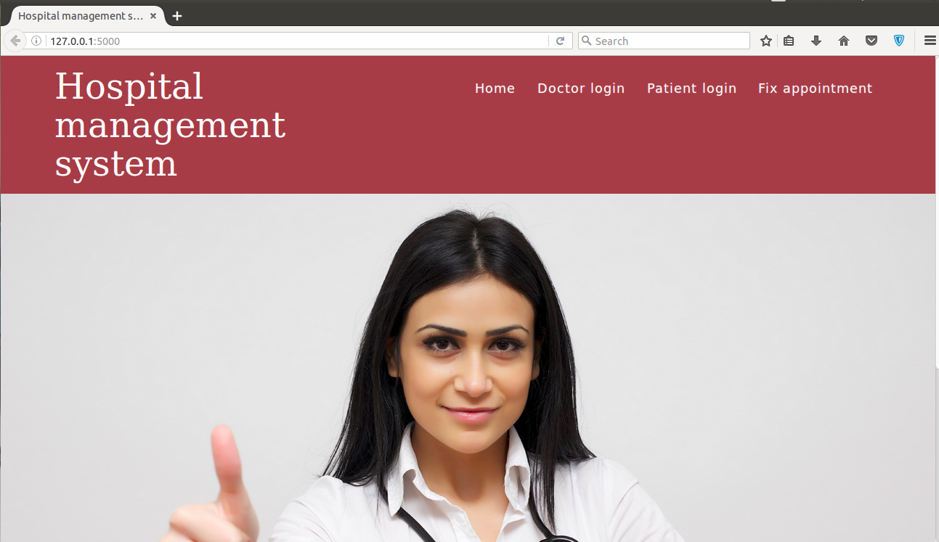

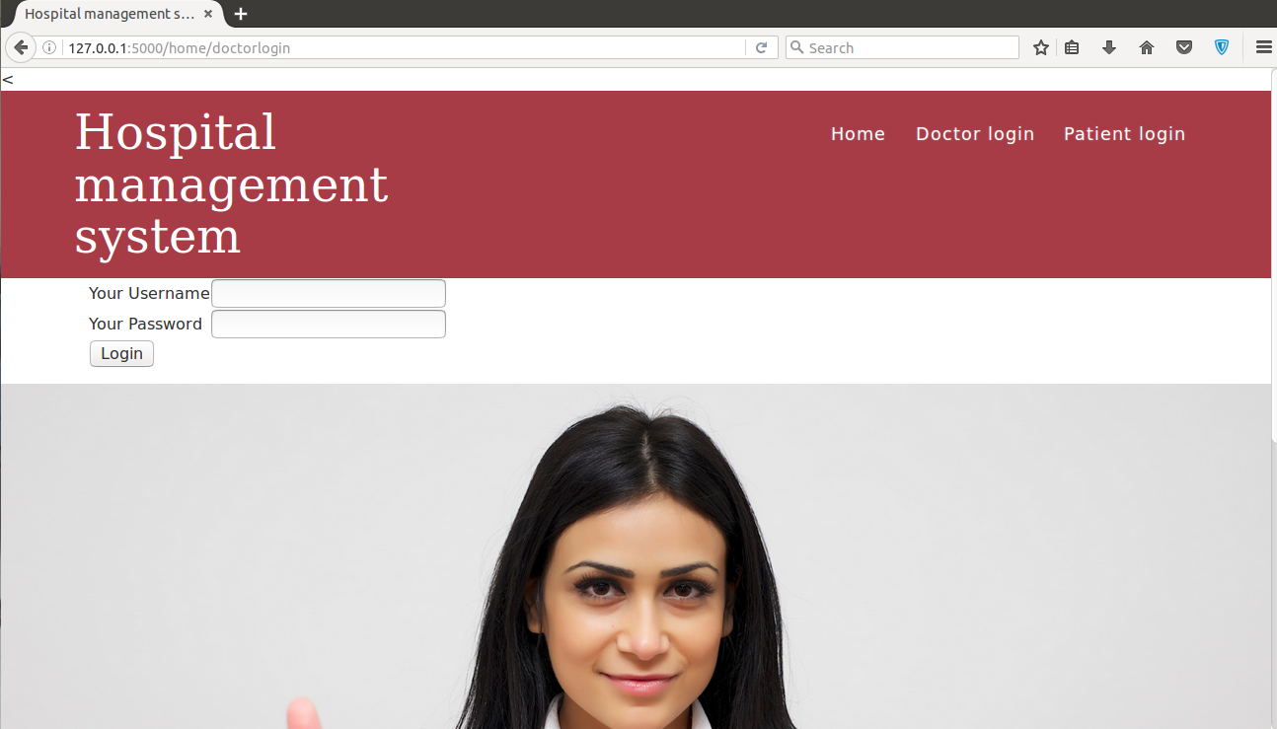

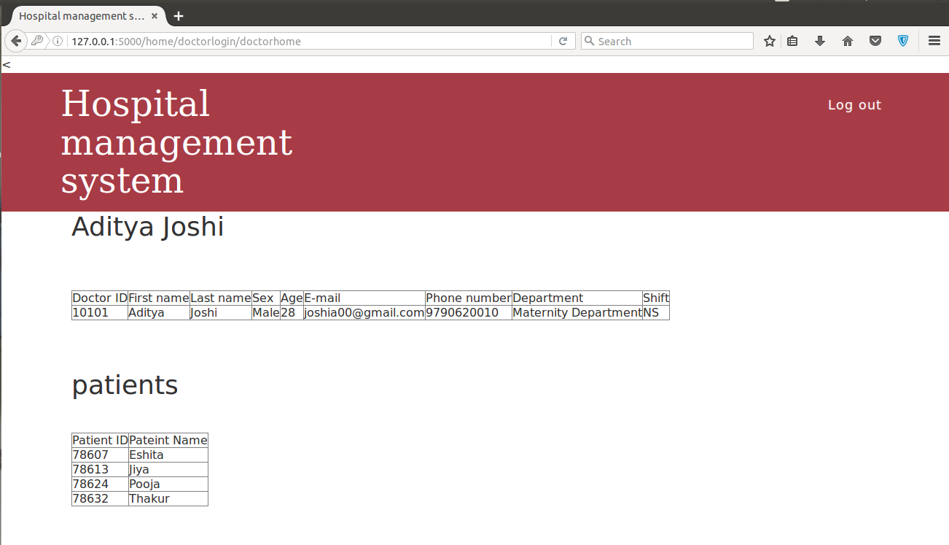

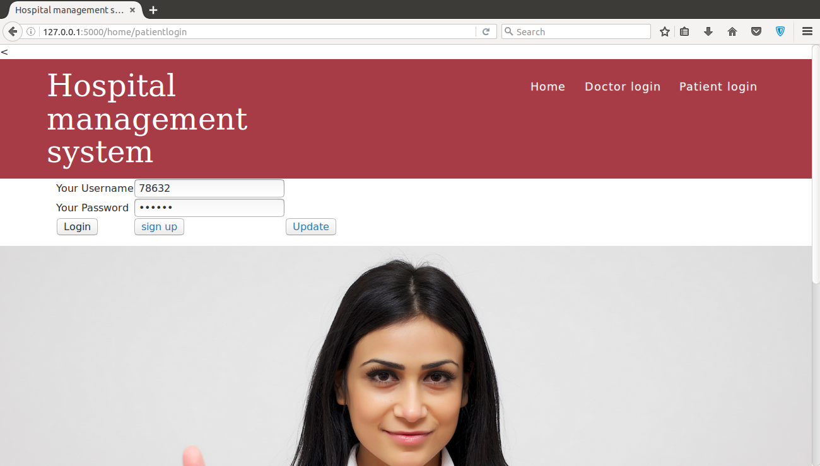

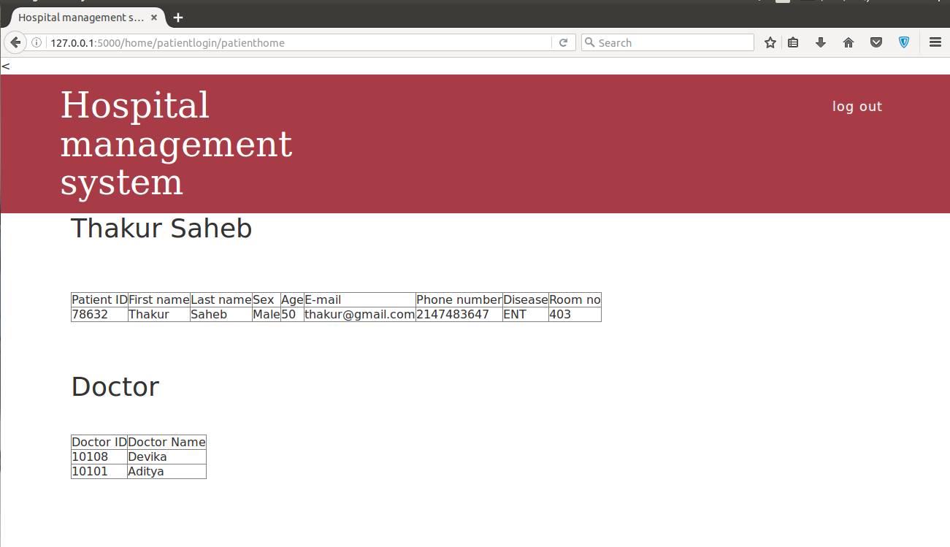

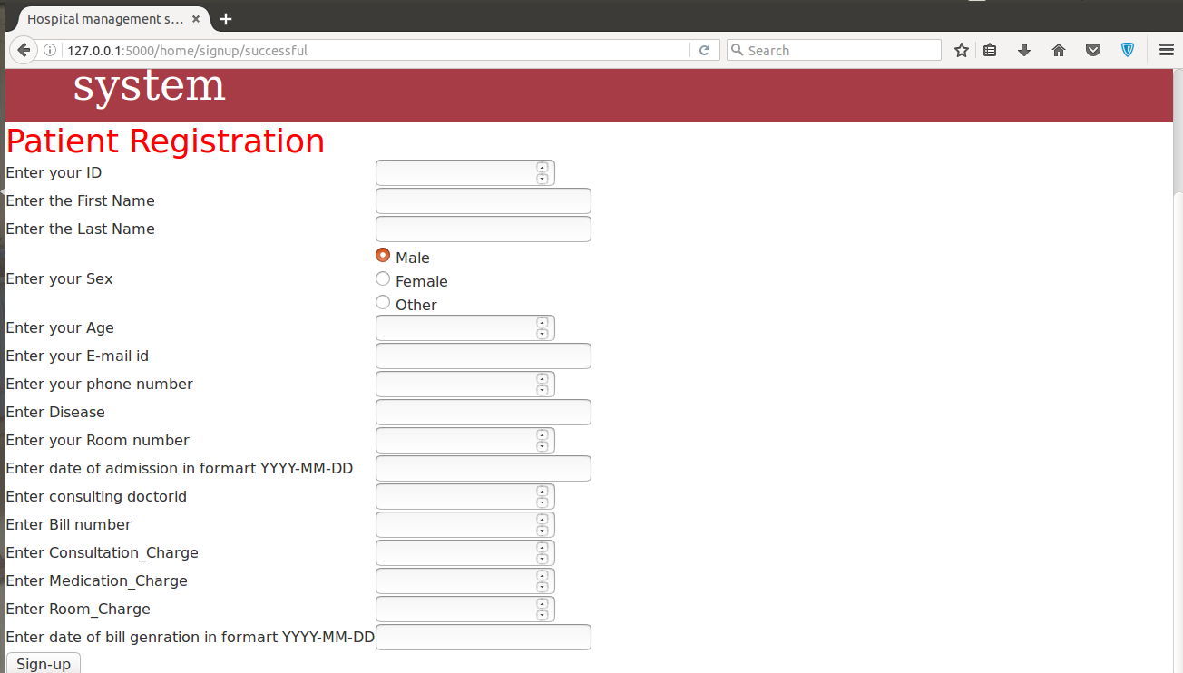

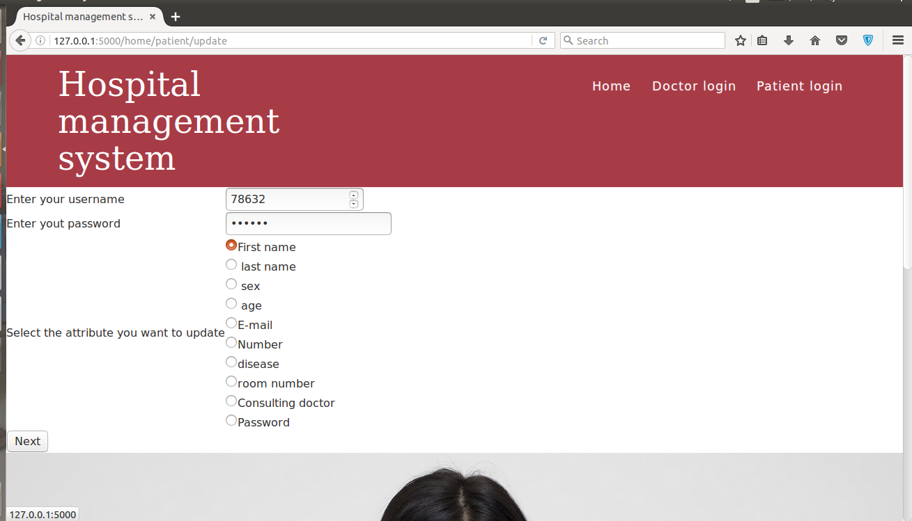

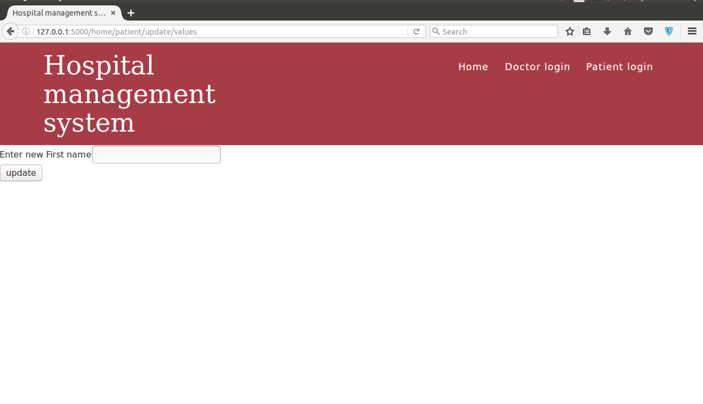

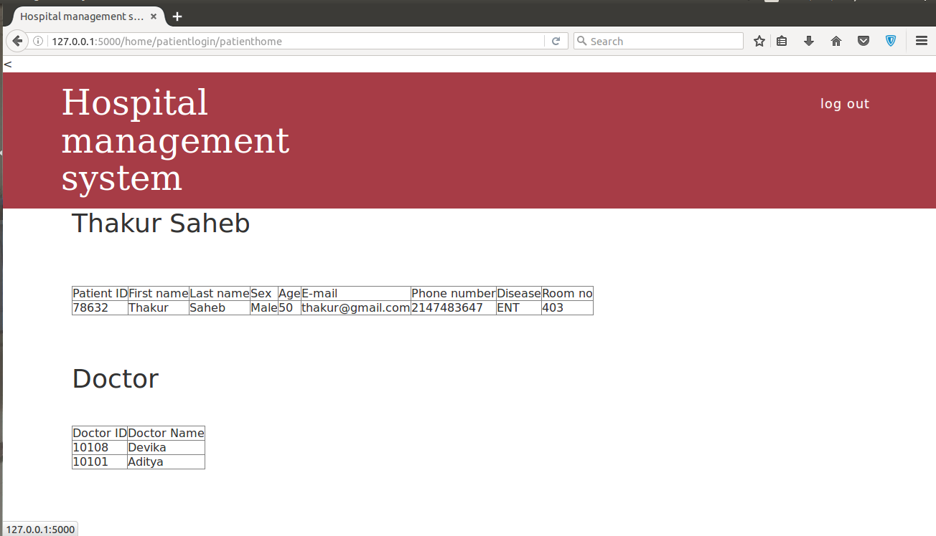

**LIST OF ABBREVIATIONS**

**Abbreviation Expansion**

WWW World Wide Web

http Hyper text transfer protocol

db database

cur cursor

**ABSTRACT**

Our project Hospital Management system includes registration of patients, storing their details into the system, and also computerized billing in the pharmacy, rooms, doctors chargers. Our product has the facility to give a unique id for every patient and stores the details of every patient and the Doctor automatically. It includes a search facility to know the current status of each room. User can search availability of a doctor and the details of a patient using the id. The Hospital Management System can be entered using a user and password. It is accessible either by an Patient or Doctors. Only the registered patients can add data into the database and fix appointments. Patients can use their Id and password to access their records and update their data. The data can be retrieved easily. The interface is very user-friendly.

The current products available in market does not focus more on the security of the database of patients and doctors. Also, currently available products are not very patient friendly. This product is made more patient friendly. Where, they can view their record, update their records and fix appointments with doctors. The product is made secure with the use of hashing. We have used SHA1 algorithm which is currently used in most of the security applications.

1. **Introduction**

This website is going to be a place where both doctors and patients can interact with each other. The product is focused to decrease the complexity of conventional pen and paper system which takes more time and gives extra strain to the patient. So, we define our product as a place where all the patients and doctors can interact freely. Our product is focused on saving patients from long queues.

1. **Theoretical background:**

In this project we have used Python flask for making a web server, HTML and CSS for creating a static website and we have our database on MySQL. Along with these we have use SHA1 hashing algorithm which is a 160bit algorithm and has established itself as one of the most reliable hashing algorithm. Which has made it the most used algorithm in the world right now. The basic knowledge of mysql database is also required in understanding this project.

1. **Motivation:**

Our main motivation for doing this project was to provide a network where each and every patient can connect to each and every doctor and without going into long queues. There is already stress on a sick persons mind and queues and other things do nothing but increases it.

1. **Aim:**

Our aim is to make a small version of a hospital database where we can handle and manipulate data with the help of a python script. Along with the handling of data we are trying to understand how the hospitals are able to secure the data within their database. The hospitals deal with numerous amount of patients daily. So, this mini version of hospital is made to understand the dealing of data within hospital.

1. **Objectives of the proposed work:**
   1. The idea is to create a platform which can allow patients to deal with the technicalities of a hospital easily.
   2. To make a system to eliminate paper based record system which is not secure and a software based database.
   3. To help patients meet the doctors easily and save their time and energy.
   4. To helps doctors keep an eye on their patients by without meeting them through a Mysql based database**.**
   5. Creating a secure system for everyone. Creating a database where the right person only can access the information.
   6. New people can sign up for the hospital and take appointments with the doctors.
   7. A patient can update it's previous record.
2. **Report Organization:**Hospitals are a big part of our life. Everyday thousands and lakh of people visit hospitals to get proper treatments. To think of it, that hospitals manage such huge amount of data daily. We decided to make a pseudo mini hospital where we understand how the patients and doctors are related within the database, also we wish to examine how a person which in not part of the hospital i.e. He/She is neither a patient or Doctor can meet Doctors for appointments.

**2.Literature survey**

1. **Survey of the Existing Models/Work:**

|  |  |  |  |  |
| --- | --- | --- | --- | --- |
| **Authors** | **Method** | **Purpose** | **Advantages** | **Disadvantages** |
| Premkumar Balaraman, Kalpana Kosalram | Use of HIS model | To identify the key componens of E Hospital  Managemnt solutions | Handle the workflow of daily medical  services and also assist in managing financial,  administrative  and clinical data |  |
| Dr. Sudhir Rewar | 100 staff (  technical staff, consultant and clinical engineering department staff) | medical  equipment management system used for clinical engineering department | improved the operation management of medical devices immediately and continuously | retention model based accuracy improvement |
| Christopher Bain  [3] | using the technology  ecosystems mode | hospital management technology  ecosystem (  a HOME) | Accuracy is greater than discriminative analysis method, ability to classify with improved accuracy | performance degradation |
| E.ARUL BENJAMIN CHANDRU | automate ward entries | To decrease the processing time | Fast proccessing | Data degradation |
| Olusanya Olamide | database, object  -  oriented programming language and networking techniques. | To make computerized hospital management  system | enable faster diag  nosis with  ready  -  made templates | Performance degraded by increased number of attribute selection |
| R. Peter Heine  Stetson University | System of Number” for referencing  and saving  for future works  utomated system that is  used to manage p  atient information and its administration | Predict student performance  automated system that is used to manage p  atient information and its administration | eliminate the problem of inappropriate  data | Keeping, inaccurate reports, |
| Vincent Shaw | Naïve Byes and Decision tree classifier | develops conceptual models based on complexity science to understand the  design, | Accuracy range from 50-57% | Performance degraded after second enrolment of data |
| Ananya Roy | Automated  Alarm System for the visitor’s entry and exit within a time is  facilitated by tracking the visitor’s Media Access Control (MAC) | by using a Bluetooth connection | Effective performance prediction | optimization of network is necessary |

1. **Summary /Gaps identified in the Survey**Hospitals have become a crucial part of our daily day to day life. Even, though the montly checkup's are required, Everyone of us visits a hospital in every 6 months or a year. If, we take example of big hospitals like AIMS in New Delhi, where they have a waiting list of minimum 6 months for even incurable diseases like cancer and HIV. In such cases handling data efficiently becomes very important because even a smaller change the data can lead up to a serious damage to the patient. There are already proposed models which are in progress such as.  
   Dr Sudhir Rewar made a 100 staff (technical staff, consultant and clinical engineering department staff) system in which he focuses on the different Departments, the system was a success as it keeps an eye for improved management for Medial instruments immediately and continuously. Like this there are different models in the market which focus on the different needs.   
   These models are proposed to process data fast without any losses. We have studied these models and created an optimised database which rejects any unwanted information and hence making the processing of the system fast. The current system does not focus more on the security of database. We have created a secured database which can only be accessed by the registered users.

**3.Objective**

1. **Introduction:**We have made our product very patient friendly, here a patient can view his/her details. He can also check the doctors working on him. Patient can also fix meetings and appointments with the other doctors. In addition to that the product is very secure as no other person will be able to know the details of a patient ID other than the Person with password of that ID, because the data and passwords are being stored as random string with the help of hashing.
2. **Framework, Architecture or module of the proposed system:**In the proposed model the back end database is created on MySQL, which is connected to the front end by using MySQLdb database connector to python which acts as a bridge between the front end and the back end. The front end is made using HTML and CSS, along with HTML and CSS, we have created a server using python flask, which is a python framework for creating dynamic websites. HTML templates and server are connected together using jinja templating. Which, is a method to pass python statements into HTML template, this is an inbuilt feature of python-flask library.  
   So, the user enters a query on the HTML template, which pass the query to our server where it is stored in some temporary variables. Then the server retrieves data from our database and send it back to user through HTML template.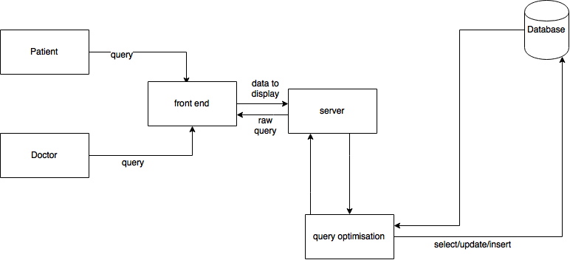
3. **Er Diagram:** 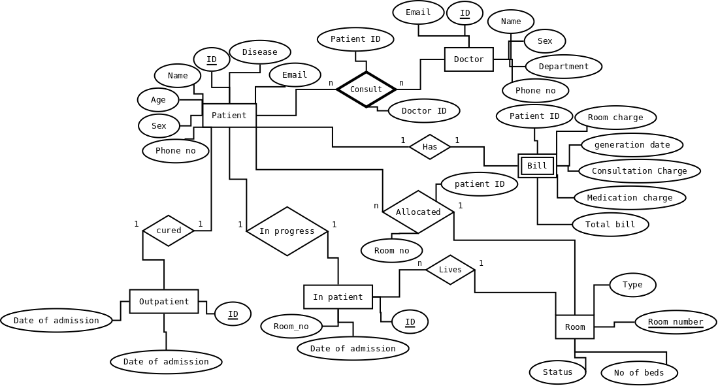

**4. Proposed system analysis and design(IEEE standard):**

1. **Introduction:**There are certain rules of IEEE standard for writing different contents that a person may want to write it in the document and different rules for everything. Going through all the specifications, rules and formats that are valid in IEEE standard we are doing the requirement analysis of our project and found out the following results that are mentioned below.
2. **Requirement analysis:**
   1. **Functional Requirements:**
      1. **Product Perspective:**The following ER diagram is perceive as the database model that we have created in our system and it is the 2 dimensional image of the model of the database. All the characters of database worked on the system is presented in this 2-D model and so. It has the content of weak entities, connection of different tables known as relationships and all the dependencies.
      2. **Product Features:**The product features two types of views, one with respect to patient and the other with respect to the doctor. The product has basic login features which include sign-up update. Along with these functionalities we also have a extra feature where a patient can fix appointments with the doctors. The product cannot cover whole functionalities of a hospital, but we have tried to complete everything.
      3. **User requirements:**There are no as such user requirements, It is made in such a way that anyone can understand the working of website. Irrespective of their knowledge of computer sciences and databases.
      4. **Assumptions and dependencies:**We take a assumption that the certain price of rooms and medication are fixed, also we have taken the assumption that this hospital has different branches, i.e. the pharmacy works separately to the main branch of the hospital.
      5. **Domain Requirements:**This product requires a system with one basic database. Since, we have made it using MySQL, So, we would recommend to use MySQL only. In addition to that system must also have python 2.7 or above. It should also have python-Flask library downloaded and MySQLdb connector library downloaded.
      6. **User Requirements:**This web server does not require any prior knowledge of computer sciences from the person using. The product is made in such a way that even a 5'th standard kid should be able to understand it easily.
   2. **Non functional requirements:**
      1. **Product requirements:**
         * **Efficiency:**The efficiency of a database model is determined by how much time it is taking to for processing the query and accessing the data stored in the database. In our system we are using about 80 entries in the patient table and who are consulting 20 doctors. Also, this database is made in such a way that we have minimised redundancy. Which, solves our problem of extra space aquired on disk. Also, we are optimising the query. So, the extra time for processing is reduced and the processing becomes fast.
         * **Reliability:**As the database and server are made differently the database and the information stored remains intact, even if the server goes down or crashes.
         * **Portability:**The product is made using MySQL and python-flask. So, It can be transferred into any system which is compatible with MySQL database and has a basic version of python in it with python-flask library installed.
         * **Usability:**The product can be used by any person who is willing to attend the hospital. There are two main users i.e. the patients and the doctors. In addition to them the general crowd can also access the product and register for the hospital and fix appointments with the doctors.
      2. **Engineering standard requirements:**
         * **Economic:**Since the product uses all open source softwares, therefore the budget of “The hospital management system” is not very high. If we plan to make a perfect working model in the real environment. There also the main cost will be on the maintenance. In other words, if we wish the product can be made cost free, with the use of open source softwares.
         * **Environmental:**The product has focused mainly on maintaining the records in software instead of using conventional paper based records and registration. Since, The project promotes to avoid the use of paper which is eventually made from trees. This project in an indirect way helping the mother earth to sustain it's greenery.
         * **Social:**Changes in modern societies originate the perception that ethical behaviour is essential in organization’s practices especially in the way they deal with aspects such as human rights. These issues are usually under the umbrella of the concept of social responsibility. Recently the Report of the International Bioethics Committee of UNESCO on Social Responsibility and Health has addressed this concept of social responsibility in the context of health care delivery suggesting a new paradigm in hospital governance. The objective of this paper is to address the issue of corporate social responsibility in health care, namely in the hospital setting, emphasising the special governance arrangements of such complex organisations and to evaluate if new models of hospital management (entrepreneurism) will need robust mechanisms of corporate governance to full fill its social responsiveness. The scope of this responsible behaviour requires hospitals to full fill its social and market objectives, in accordance to the law and general ethical standards. Social responsibility includes aspects like abstention of harm to the environment or the protection of the interests of all the stakeholders enrolled in the deliverance of health care. In conclusion, adequate corporate governance and corporate strategy are the gold standard of social responsibility. In a competitive market hospital governance will be optimised if the organization culture is reframed to meet stakeholders’ demands for unequivocal assurances on ethical behaviour. Health care organizations should abide to this new governance approach that is to create organisation value through performance, conformance and responsibility.
         * **Political:**It's always better to keep things like hospitals and schools away from school, but during the time elections, there is always a chance of riots, especially in a country like India. So, a fast registration and appointment fixing mechanism will really help hospital to keep up with the large of patients.
         * **Ethical:**The Product will help patients to relax and not to worry about getting into long queues to check their details or fixing appointments. They can do it on their laptop itself. By, sitting at home.
         * **Health and safety:**Hospitals are directly related to the health care and safety of the people. The product depicts a smaller version of hospital, where anybody can register and get their appointments fixed.
         * **Sustainability:**We all agree that internet has affected us in such a manner, that nothing has escaped it's influence. Condition now is that we arre trying to make everything online. Which, is for the better of our society. So, this product is also a step towards reducing work on paper and making it online. The product is made is such a way that it can sustain itself in the market, when the demand of online records and system increases.
         * **Legal:**We, have kept every legal aspect in mind while developing this server. This product requires no special legal attention. As, the softwares used in this are all open source and are free for everybody.
         * **Inspectability:**Our project sees each and every aspect of the consequences and results in a detailed manner. After all the inspection we have made this project.
      3. **System Requirements:**
         * **S/W Requirements(details about Application Specific Software):**We have used following softwares to develop this product  
           + **Python-flask:**  
             This is used to create a server also this acts as a bridge between both front end and back end. That is between MySQL database and HTML template.
           + **MySQL:**MySQL is used to create a pseudo database of a hospital. The software is used because of its simplicity and it is free of cost.
           + **MySQLdb library:**It is a python library which is used to connect MySQL database and python script in which my flask library operates.
           + **HTML/CSS:**Used to create front end and CSS to make it look good.
           + **Dia Diagram developer:**Used to create a two dimensional graphical model of the database. And to develop necessary framework.
           + **Linus ubuntu operating system.**

**5. Results**

1. **Sample test Case:**Test cases of The hospital management system.  
   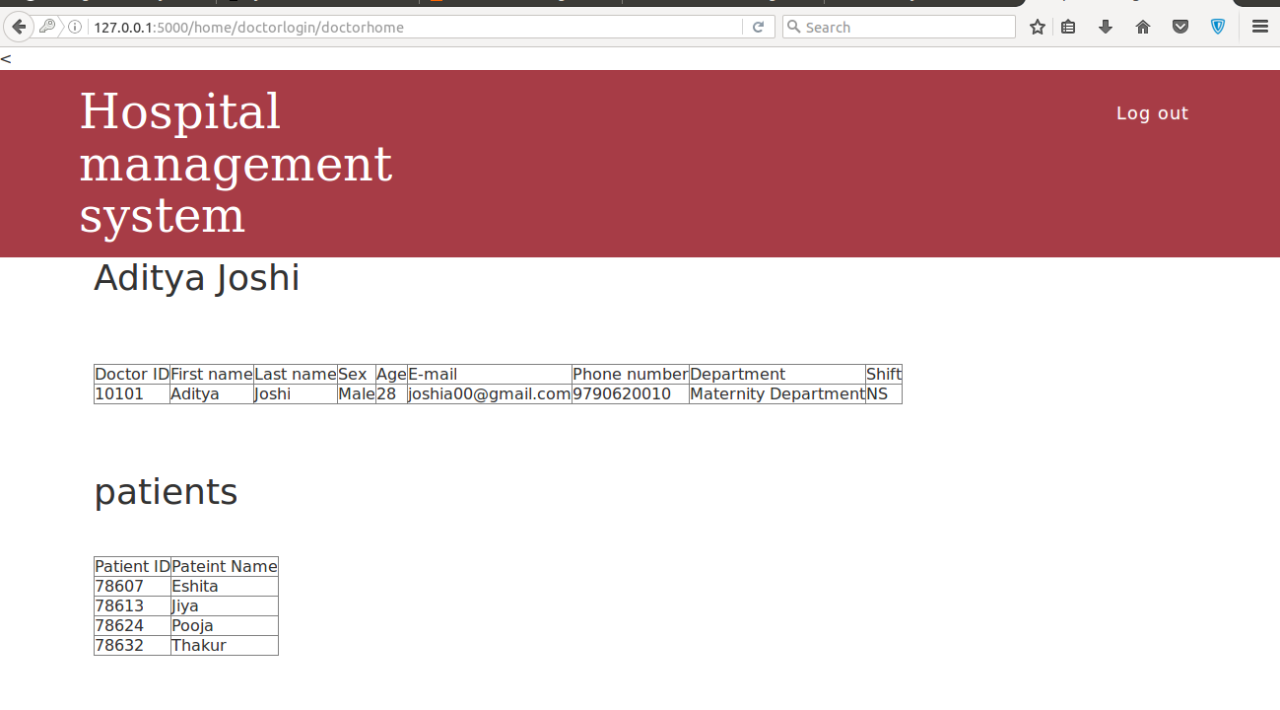

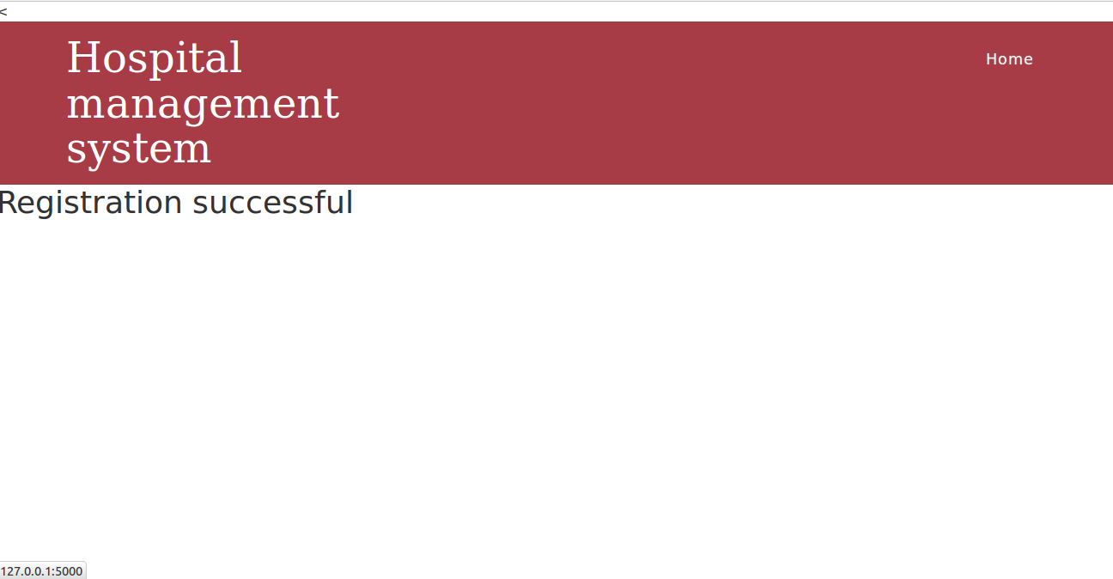

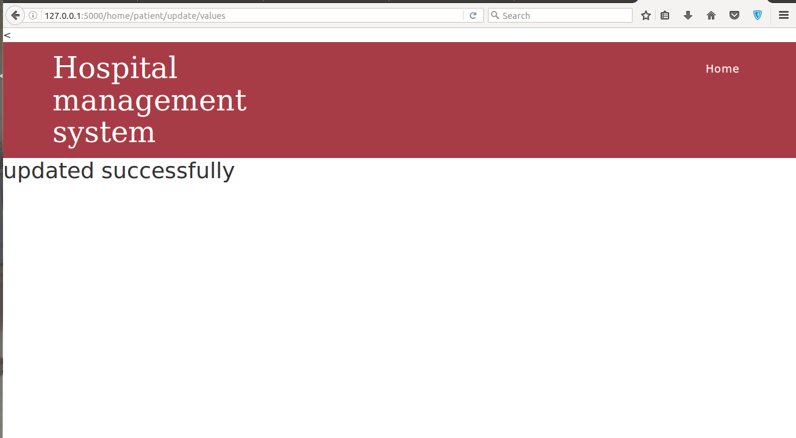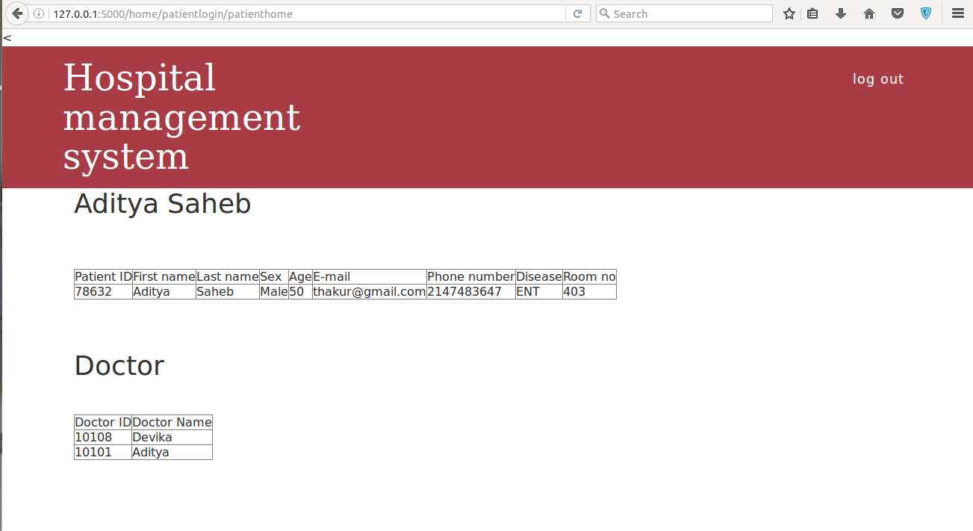

1. **Summary of results:**The results pictures shown above proves that “The hospital management system” is working perfectly. The doctors are able to see their working details which include their ID, first name, last name, sex, age, Department and the shift he us working in. Also, we can see that the details of an employee are successfully updated. There is no problem in signing up to the hospital and fixing appointments with doctors as well. The system works perfectly having a perfectly synchronous database and web page. The data is perfectly sent to the database, where we have no difficulty in storing it.

**6. Conclusion, limitation, scope for future work:**

In the end we were successful in making our system work properly. The project helped us learn many things. We learned many things in the process, such as we learned how to create a website using python-flask, for the security purposes we learned SHA1 algorithm of hashing and most important we learned how to connect front end and the back-end of a database.

**7.References:**

1. <https://www.google.co.in/url?sa=t&rct=j&q=&esrc=s&source=web&cd=3&cad=rja&uact=8&ved=0ahUKEwjitIDk7I7QAhWKso8KHdh6Cm4QFgglMAI&url=https%3A%2F%2Ffonts.google.com%2F&usg=AFQjCNFZ_NfKLA94UoMjlCiMk1Pev7-U4A&sig2=r9Fv7Yj27hAYF_543QcUig>
2. <https://www.google.co.in/url?sa=t&rct=j&q=&esrc=s&source=web&cd=1&cad=rja&uact=8&ved=0ahUKEwihgNX47I7QAhUIrY8KHVyKDWgQFggcMAA&url=http%3A%2F%2Fwww.tutorialspoint.com%2Fflask%2F&usg=AFQjCNFIbRqCMWhaUW3dJt3-FcdG963RMA&sig2=c1_Ve_q1XQrI6FuOj8ac1Q>
3. <https://www.google.co.in/url?sa=t&rct=j&q=&esrc=s&source=web&cd=1&cad=rja&uact=8&ved=0ahUKEwiB6sWG7Y7QAhUJuI8KHcrkCyoQFggcMAA&url=http%3A%2F%2Fwww.w3schools.com%2Fsql%2F&usg=AFQjCNF2-zIxgQyzqwxy2j7n29JyngSdWg&sig2=UUwGHfQLlXNLFaIZtgOD_A>
4. [https://www.google.co.in/url?sa=t&rct=j&q=&esrc=s&source=web&cd=1&cad=rja&uact=8&ved=0ahUKEwi3q4KP7Y7QAhVLMY8KHXxLA3AQFggfMAA&url=http%3A%2F%2Fmysql-python.sourcegforge.net%2FMySQLdb.html&usg=AFQjCNFu0ivIzsfU0ItOc-xxH9ViwZBiVg&sig2=mMwNCwKWUu2N8rdCPfDn_](https://www.google.co.in/url?sa=t&rct=j&q=&esrc=s&source=web&cd=1&cad=rja&uact=8&ved=0ahUKEwi3q4KP7Y7QAhVLMY8KHXxLA3AQFggfMAA&url=http%3A%2F%2Fmysql-python.sourceforge.net%2FMySQLdb.html&usg=AFQjCNFu0ivIzsfU0ItOc-xxH9ViwZBiVg&sig2=mMwNCwKWUu2N8rdCPfDn_g)
5. <https://www.google.co.in/url?sa=t&rct=j&q=&esrc=s&source=web&cd=1&cad=rja&uact=8&ved=0ahUKEwjsn8Ga7Y7QAhVEv48KHSS3BPkQFggfMAA&url=http%3A%2F%2Fflask-mysqldb.readthedocs.io%2F&usg=AFQjCNGxx_I1RgGOfF3M7ss-H3_uaqMtyA&sig2=j06G4tX9xy0LOL5Ze4quvQ>